Add new buyer / procurement staff in Georgia Procurement Registry (GPR)
Step # | Action
1 | Login to GPR. Link: https://ssl.doas.state.ga.us/PRSapp/PR_login.jsp
2 | Click on ‘Main Menu’. (Upper left corner or bottom left corner)  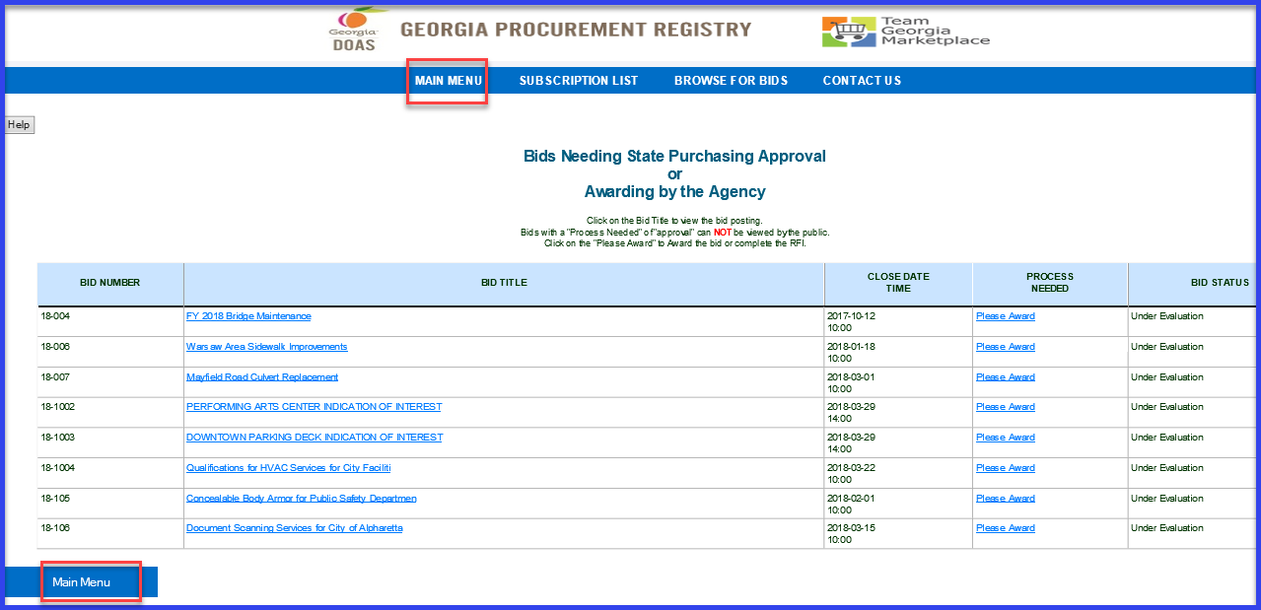
3 | Click on ‘Add Buyer or Procurement Staff Profile’ under ‘Buyer Information’.  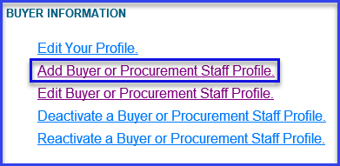
4 | Fill in the information for user such as First name, Last name, email, Title, Phone number, Address. (All field with ** are mandatory.) Leave ‘Security Type’ as ‘6—Agency Manager’ as all users will be granted this security by default.  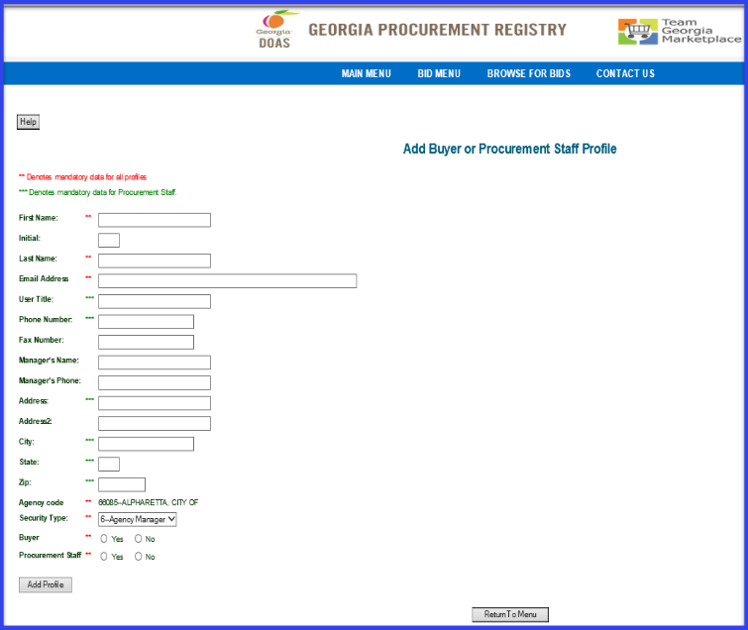
5 | Click on ‘Add Profile’ to save and create new profile for new user.
6 | Click ‘OK’ on the warning message you get to verify user’s security level.  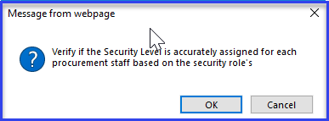
7-A | System will give on screen confirmation. User’s email address will be user’s User Id to login.  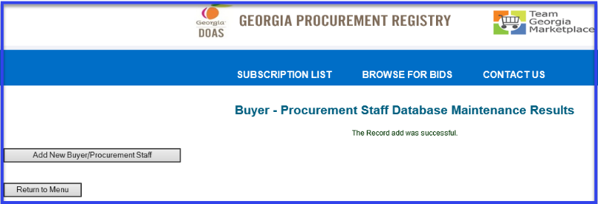
7-B | If the user’s email address is already existing in the database system will not allow you to add profile with same email address, as user’s email is unique identifier.  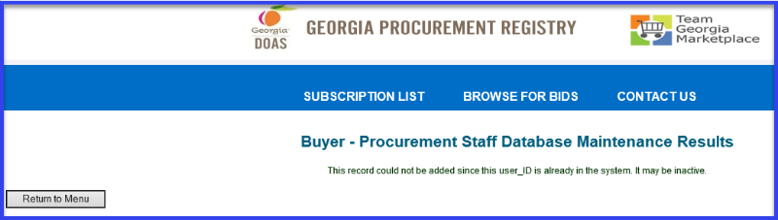
8 | User will get email notification as confirmation for registration with temporary password and link to GPR.  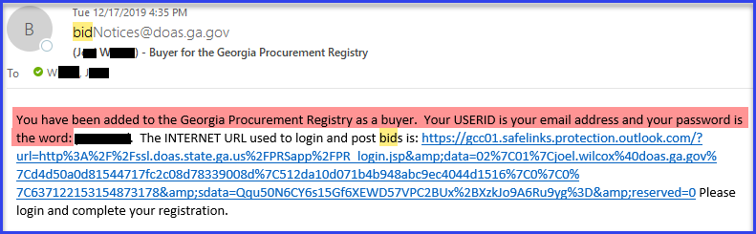
 | End process.

